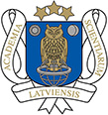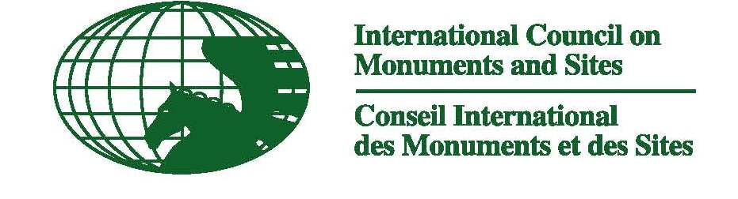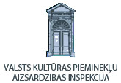
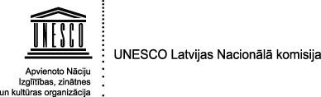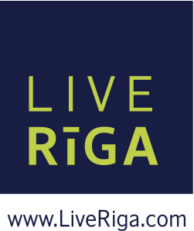

ICOMOS International Scientific Committee
Theory and Philosophy of Conservation and Restoration
9th Annual Meeting & Scientific Conference
„Heritage Trends in the Mirror of Social Change.
Conservation Reality – 50 Years after Venice Charter”
May 8 – 10, 2014
Riga, Latvia

Preliminary programme
Thursday, May 8, 2014
10.00 – 11.00 | Arrival coffee in Latvian Academy of Sciences, Academy Square – 1  Registration of Participants
11.00 – 13.00  11.00 – 11.15  11.15 – 11.30  11.30 – 12.00  12.00 – 12.30  12.30 – 13.00 | Opening session in the Portrait Hall, 3-rd floor  Ojars Sparitis (Riga, Latvia): Welcoming Address.  Wilfried Lipp (ISC Theory President): Introductiom.  1. Imants Lancmanis ( Latvia):  Social paradigm in protection of manors and residential palaces in Latvia  2. Jānis Krastiņš ( Latvia):  Art Noveau heritage in Riga in European context of conservation theories  3. Jānis Dripe (Latvia):  Perspectives of Riga architectural and spatial development in traditional historical urban landscape
13.00 – 13.30 | Discussion
13.30 – 14.30 | Lunch in the Buffet of Latvian Academy of Sciences
14.30 – 17.00 | Afternoon session  Section I (Portrait Hall)  European experience in conservation and  maintenance of heritage of architecture  1. Wilfried Lipp (Austria):  The Charter of Venice - Retrospect and Preview.  2. Jukka Jokilehto (Finnland):  The question of universality in the international conservation doctrine.  3. Sergiu Nistor (Romania):  The Venice Charter – A Mirror to Social and Political Changes in Eastern Europe.  4.Javier Gallego Roca (Spain):  Around the Charter of Venice: the conservation of the architectural heritage of Granada and the value of authenticity  5. Gamini Wijesuriya, (Sri Lanka, ICCROM):  Time to say Thank you to Venice Charter  6. Vahid Reza Eslahi, (Iran):  Research – 50 Years after Venice Charter. Challenges and Solutions - Past and Future.  Section II (Senate Hall, 2-nd floor)  Complex restoration of architectural ensembles in urban and vernacular space  1. Willem Derde, (Belgium):  Towards an agenda for heritage conservation in the 21st century: reflections on Europe and Asia  2. Jyoti Hosagrahar, (USA, India):  Historic Cities under Siege: Postcolonial Perspectives  on Urban Heritage from South Asia  3. Netice Yıldız, (Cyprus):  Protection of the Cultural Heritage of Cyprus, a Divided Island  4. Rosa Anna Genovese, (Italy):  Experiences in conservation of architectural heritage compared before and after the Venice Charter  5. Vishakha Kawathekar, (India):  Reality to expected realm of protection of built heritage in India
17.00 - 17.30 | Discussion
17.30 – 18.00 | Coffee break (Portrait Hall, 3-rd Floor)
18.00 – 20.00 | Walking Tours:  A – Riga Old Town (By Ojars Sparitis);  B – Art Noveau architecture (By Janis Krastins)
20.00 – 22.00 | Reception hosted by “Live Riga” in the Hotel Restaurant ASTOR, (Z.A. Meierovica Boulevard - 10).
Friday, May 9, 2014
9.00  9.00 – 11.00  11.00 – 12.00 | Sections No. 1. and No. 2. Departure from Latvian Academy of Sciences to Turaida Castle. Continuous conference.  Section No. 3. Excursion over sites of Riga urban structures and objects of postwar architecture. Start at the Latvian Academy of Sciences.  Moderators: Dr. Janis Lejnieks, Ilze Martinsone, Vita Banga  Transfer to Turaida Castle
10.00 | Sections No. 1. and No. 2. Arrival in Turaida Castle. Coffee.
10.30 – 12.00 | Anna Jurkane, Director of Turaida Museal complex (Riga, Latvia)  Turaida Castle and environment - Guided tour in situ. Comments on aspects of history of conservation, restoration and adaptation for cultural tourism
12.00 – 13.00 | Lunch in Turaida for all sections No 1, No. 2, No 3.
13.00 – 14.30 | Afternoon session  Section III  Philosophy of the reception of heritage after WW II  (Moderator Dr. Janis Lejnieks, Latvia)  1. Sigrid Brandt, (Germany, Austria):  Socialist Realism in Central and Eastern Europe - The “other modernism” after World War II  2. Uskokovic Sandra, (Croatia):  "Uncomfortable" significance of Socialist Heritage in postwar Croatia  3. Emilia Kaleva, Aneta Vasileva, (Bulgaria):  (Non)Heritage: The Problem with Reception of Socialist Architecture in Post-Socialist Bulgaria  4. Marko Spikic, (Croatia):  The problem of methodological identity in Croatian conservation community, 1945-1964
14.30 – 15.30 | Discussion
15.30 – 16.00 | Coffee Break
16.00 – 17.00 | Return to Latvian Academy of Sciences, Riga
17.00 – 17.30 | Coffee to all participants: Sections No. 1, No. 2, No. 3.
17.30 – 18.30 | Annual Meeting ISC Theory of Conservation - Elections  /ISC Theory Members only/
19.00 | Free evening in Riga
Saturday, May 10, 2014
10.00 – 13.00 | Meeting at the Freedom Monument.  Visit of selected sites:  - The National Opera House;  - Hotel Complex Konventhof;  - House of Black Heads Gild and Town Hall square;  - Small (Craftsmen) and Great (Tradesman) Gild;  - The Dome Church;  - Museum of European Art Riga Bourse.
13.00 | Lunch on everybody’s own
 | Departure

Introduction
To remember the 50th anniversary of the Charter of Venice, to rethink the role of social tools in motivation of restoration of cultural heritage, and to consider the positive experience in restoration of monuments of architecture after World War II ICOMOS International Scientific Committee Theory and Philosophy of Conservation and Restoration provides the annual meeting of experts in an encouraging way of traditional exchange of opinion in conference reports, as well as thematically organised work in three sections:
1. European experience in conservation and maintenance of heritage of architecture;
2. Complex restoration of architectural ensembles in urban and vernacular space;
3. Philosophy of the reception of Heritage after WW II.
The main objectives of the meeting and conference
- To remember the 50th anniversary of the Charter of Venice and to restart and activate the criteria and principles of the Charter,
- To analyse the social motivation for all works of protection of cultural heritage and restoration of monuments of architecture,
- To exchange on international level the positive experience of conservation and restoration of urban complexes and single monuments of architecture,
- To define objective criteria for protection as a documents of time and culture the heritage of post-war architecture and environment.
Venue
Thursday, the 8th of May, 2014.
Plenary meeting and work in two sections will take place in Riga, Latvia, Portrait Hall and Senate Hall of the Latvian Academy of Sciences Address: Academy Square -1, Riga, LV-1050.
An evening Reception given by “Live Riga” at the restaurant of Hotel ASTOR.
Friday, the 9th of May, 2014.
Continuation of the conference in second day on May 9th is mentioned to be hold in two places:
- for the section 1. and 2. departure to Turaida medieval castle 9.00 from Latvian Academy of Sciences, continuation of the conference papers and arrival at about 19.00.
- For the section 3. excursion through sites of postwar architecture in Riga and continuation with Lunch at 12.00 and papers at 13.00 in Turaida Castle.
Saturday, the 10th of May, 2014.
10.00 – 13.00 Riga sightseeing and visit of selected sites in the Capital of European Culture 2014. Start at the Freedom Monument.
Departure after 13.00.

Participants
Members of the ICOMOS International Scientific Committee for Theory and Philosophy of Conservation and Restoration, Latvian Academy of Sciences, Latvian National committee of UNESCO, Latvian National committee of ICOMOS, Latvian Inspection for protection of Cultural heritage, Riga Municipal office for marketing and advertisement culture “Live Riga”, Latvian Academy of Arts, Riga Technical University, museums of Latvia, media representatives.
Organizers
Latvian Academy of Sciences, Latvian Academy of Arts, Architects Society, Latvian National committee of UNESCO, Latvian National committee of ICOMOS, Latvian Inspection for protection of Cultural heritage, Riga Municipal office for marketing and advertisement culture “Live Riga”.
Framework of the meeting
Ordinary conference with papers and PPT presentations, sightseeing tours, exchange of experience and contacts, acquaintance of heritage protection in Latvia
Working language
Language – english
Excursions and sightseeings:
- Thursday, May 8th, 2014 from 18.00 to 20.00: Guided tours through Riga Old Town and Riga Art Noveau architecture.
- Friday, May 9th, 2014 for the sections No. 1 and No. 2 second conference day transfer to Turaida castle by bus at 9.00 from Town Square. Return at 17.00
- Friday, May 9th, 2014 for the section No. 3 Bus trip and visit of selected monuments of postwar architecture at 9.00 from the Latvian Academy of Sciences. Tansfer to Turaida Castle 11.00-12.00, joint lunch and continuous programm for all sections No. 1, No. 2. and No. 3.
- Saturday, May 10th, 2014 – from 10.00 to 13.00 walking sightseeing tour for acquaintance sights in Riga Old Town. Start at the Freedom Monument.

Participation

Travel expenses, hotel,meals – on everybodies own.
Bus transfer on Friday the 9th of May from Riga to Turaida Castle and return, as well as bus tour for visit monuments of postwar architecture in Riga – admission free.
Emphasized hotel - 5 minutes walk from the railway station and 2 minutes walk from Latvian Academy of Sciences: „Hanza Hotel” Elijas Str. 7, Riga, LV-1050,LATVIA
Phones: +371-6779 6040 or +371-2707 1098;
e-mail: reservations@hanzahotel.lv

Registration and Contact information
Registration:
Chair of the Department for Foreign Affairs Mrs. Anita Draveniece
Phone: +371-67227391 e-mail: int@lza.lv e-mail: lza@lza.lv
Latvian Academy of Science, Academy Square – 1
Riga, LV-1050, LATVIA or
Ojars Sparitis, Latvian Academy of Science, Academy Square – 1
Phone: +371-67225361 osparitis@gmail.com )
Conference Programme Information:
Email: isctheory@gmail.com
For questions please contact Prof. Dr. Wilfried Lipp and Prof. Dr. Boguslaw Szmygin
(e-mail: icomos.austria@gmail.com and szmygin@poczta@onet.pl ) .

